Kaushik Dey

Kaushikdey1984@yahoo.com

data visualization with python

IBM Data Science Professional Certificate

1. Yearly Airline Performance Report and year as 2019

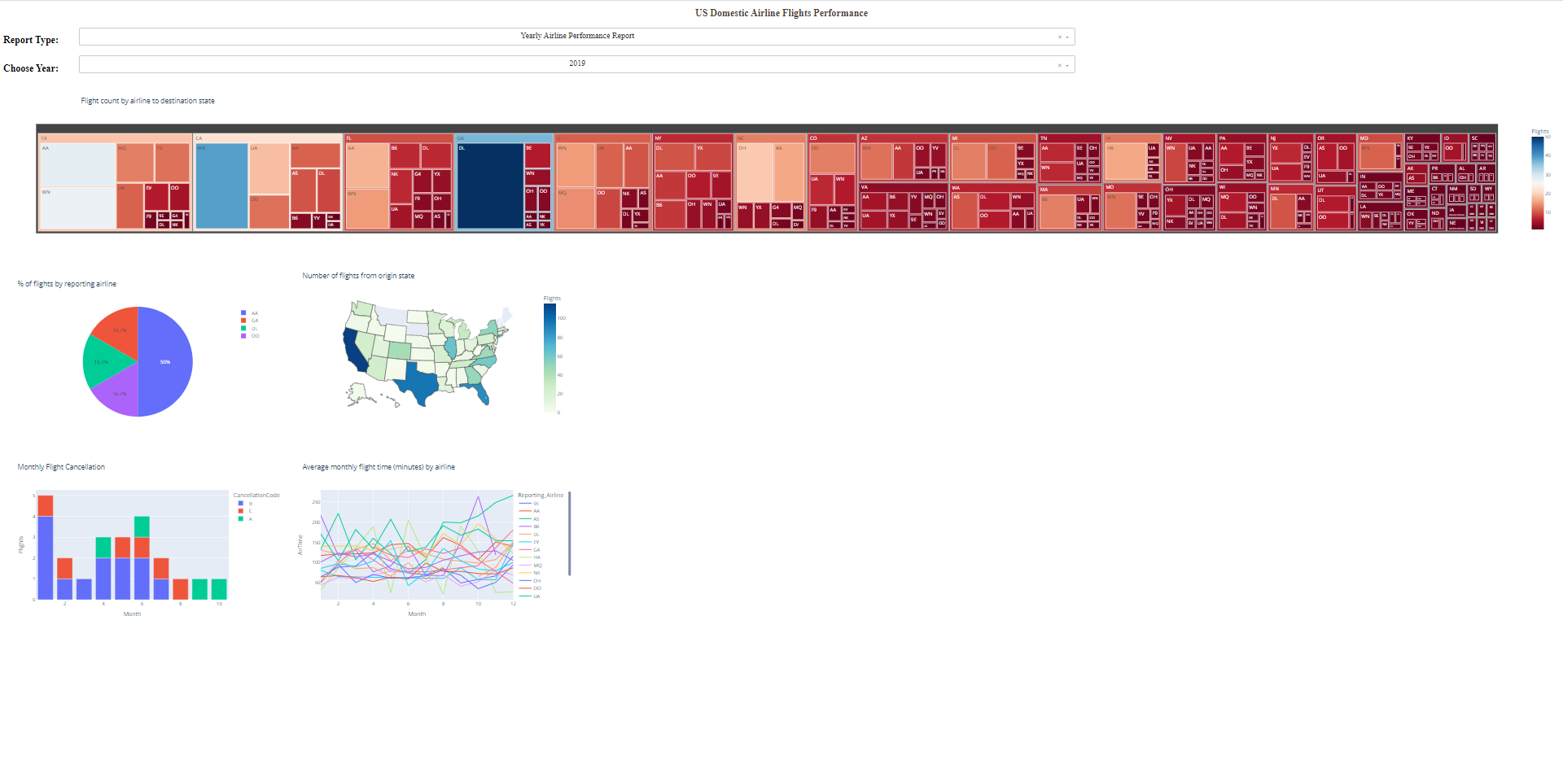

1. Yearly Airline Performance Report and year as 2015

1. Yearly Airline Delay Report` and year as 2019

1. Yearly Airline Delay Report` and year as 2008

